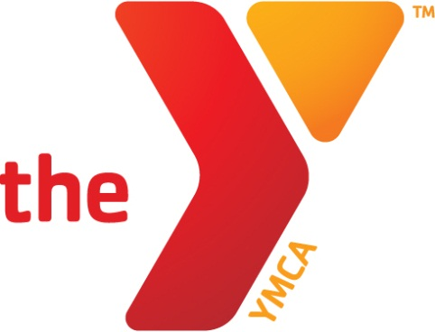

BETTER HEALTH
THROUGH
BETTER LIVING
KANKAKEE AREA YMCA
MEMBER HANDBOOK

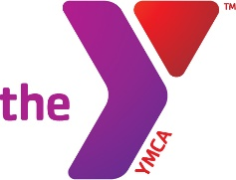
WELCOME
Thank you for choosing your Kankakee Area Y.
At the Y, you will have the opportunity to make friends, have fun, get active and discover who you are and what you can achieve. Our activities, which range from youth and adult sports and summer day camps to mentoring and leadership development, will give you the opportunity to have a healthier, happier tomorrow.
Often members tell me that once engaged as a Y member, the benefits of belonging to the Y far exceed the initial reasons for joining. By focusing on youth development, healthy living, and social responsibility, we’re working to improve the quality of life for everyone in our service area. We’re making sure children and teens have the assets and support they need to reach their full potential. We’re teaming up with organizational partners to provide individuals the programs and services they need to improve their physical, mental, and spiritual health. We’re working with individuals and families throughout the community to make sure they have the resources they need to learn, grow, and thrive.
The Y is powered by volunteers who serve on our board, coach youth sports, teach fitness classes, instruct adults and kids in aquatics, and donate professional services. Adults who can also give back are a true gift for our children and the community’s future.
If you have the ability to give or want to help raise money to fund Y programs or support participation for children and families, please let our staff connect you to others who also want to make a difference.
As a new member, we have given you guest passes to invite your family and friends to join you in building healthy habits–be sure to invite them right away so they can enjoy all the Y has to offer.
Please enlist any one of our staff to provide the information and help you need to get started with the Y. Whether its water aerobics, yoga or a core strengthening plan for yourself, physical fitness programs for the kids or a rewarding volunteer opportunity, we’re certain that you will find that the Kankakee Area Y has something everyone can enjoy.
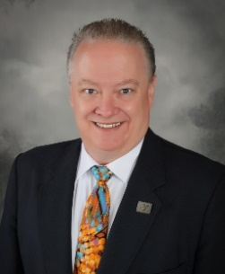
Yours in Y service for all,

William (Will) Welsh
CEO, Kankakee Area Y
TABLE OF CONTENTS

The Y is For… 4
Building Hours 4-5
Supervision of Children 5
Membership Benefits 6-7
Membership Information 7-10
Card/Categories/Refer a Friend/Dues 7
Financial Assistance/Corporate/Status Change/
Guest Privileges/ AWAY Program 8
Transfers/Child & Youth Access/Child Watch/
Lost & Found/Special Needs/Towels 9
Y Literature/Smoking Policy/Comments/Rentals/
Emergency Procedures/Accidents/
Sex Offender Background Checks 10
Code of Conduct 11-12
Facility Information 12-16
Aquatics 12
Group Exercise 13
Group Cycling/Gym 14
Locker Rooms/Racquetball Courts 15
Running Track 16
Wellness Center 17
Program Information 18-19
Strong Kids Campaign 19
Volunteering 20
Facility Maps 21-22

THE Y IS FOR…

YOUTH DEVELOPMENT
The Y is the starting point for many youth to learn about becoming and staying active while developing healthy habits they'll carry with them throughout their lives. These benefits are far greater than just physical health, for they impact all aspects of daily living.

HEALTHY LIVING
Serving families has always been at the heart of the Y. The Y wants you to live healthy. Get started, intensify your workout, eat smart and find balance in your life. Let us help you today! Connect with friends, new and old, to get fit and engage in friendly competition.

SOCIAL RESPONSIBILITY
We are a powerful ally and advocate for our communities. Our experiences and strong relationships in 10,000 neighborhoods across the nation mean that we are able to organize grassroots efforts and influence public policy around a range of social issues including child welfare, education and public health.

The Y is you - the generosity of others is at the core of our existence. It is only through the support of our hundreds of thousands of volunteers and public and private donors that we are able to give back to the communities we serve.

BUILDING HOURS

Fall/Winter Building Hours (Labor Day - Memorial Day)
Monday-Thursday 4:30am - 10:00pm
Friday 4:30am - 8:00pm
Saturday 7:00am - 5:00pm
Sunday 8:00am - 5:00pm
Youth Hours
Ages 9-13 can use the YMCA without an adult during the following hours:
Monday- Friday 4:00pm - 8:00pm
Saturday 8:00am -12:00pm
Summer Building Hours (Memorial Day - Labor Day)
Monday- Thursday 4:30am - 9:00pm
Friday 4:30am - 7:00pm
Saturday 7:00am - 5:00pm
Sunday 8:00am - 5:00pm

Youth Hours
Ages 9-13 can use the YMCA without an adult during the following hours:
Monday- Friday 8:00am - 12:00pm
4:00pm - 7:00pm
Saturday 8:00am - 12:00pm

Youth can use the facility anytime if accompanied by an adult/legal guardian who is a member of the YMCA.

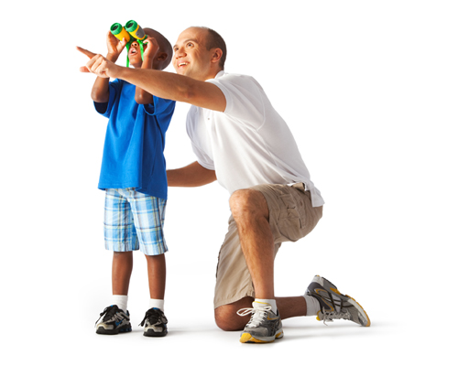
Holiday Access
The Y is Closed on the Following Holidays:
Christmas
Easter

Holiday Building Hours:
New Year’s Eve 6:30am - 11:00am
New Year’s Day 6:30am - 11:00am
Memorial Day 6:30am - 11:00am
Good Friday 6:30am - 11:00am
Fourth of July 6:30am - 11:00am
Labor Day 6:30am - 11:00am
Thanksgiving 6:30am - 11:00am
Christmas Eve 6:30am - 11:00am

Supervision of Children
Children eight years of age and younger must be with a parent or guardian, or in a class, structured program, Child Watch, or Youth Center. Parent or guardian must remain in the building.

Certain areas of the Y are restricted to use by specific age groups or restricted by specific supervision guidelines—such as the Wellness Center, swimming pool, etc. Please check with the Y for details.
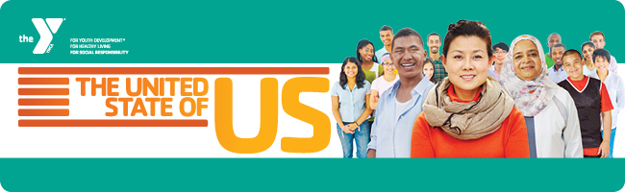

Membership Benefits

At the Y, we are committed to strengthening the foundations of community by providing programs based on four basic character values—caring, honesty, respect, and responsibility. For more than a century, the Kankakee Area YMCA has contributed to the lives of hundreds of thousands of boys, girls, men and women of all races, religions, and economic backgrounds. We are a not-for-profit organization with the unique opportunity to touch lives from infants through seniors.

Part of a worldwide movement in more than 124 countries, our mission is to put Christian principles into practice through programs that build a healthy spirit, mind and body for all. Through the years, lifestyles and family structures have changed and will continue to change. Our programs will always reflect the changing needs of the communities we serve.

Thank you for choosing the Kankakee Area YMCA for your family’s program and fitness needs. We consider it a privilege to serve you.

Benefits Include:
- Free Personal Training
- Free Group Cycling classes
- Free Wellness Center orientation
- Free Land & Water Aerobics Classes
- Free Child Watch & Youth Center
- Free Family Fun Events
- Free open swim and gym time
- Free towel service
- Complimentary coffee service
- Membership credit when you refer a friend
- No Contracts to sign
- YMCA Character Values incorporated into all programs
- A place to become connected and build friendships that last a lifetime
- Reduced member rates for classes and programs
- Priority program registration and the ease of online registration
- AWAY privileges, Always Welcome At YMCAs
- State-of-the-Art Aerobics Studio
- Cardiovascular Equipment
- Free Weights
- State-of-the-Art Cybex & BodyMaster Strength Equipment
- Gymnasium
- Opportunities to serve, volunteer, and make a difference
- Indoor Running/Walking Track
- 3 Racquetball/Handball Courts
- Indoor Play Center – Charlton Kids’ Fit Zone

- Two Indoor Pools
- Therapy/Instructional Pool, kept around 90 degrees, is ideal for youth swim lessons, exercise programs, and adapted training.
- Fitness Pool, kept around 84 degrees, is ideal for fitness swimming, swim clubs, and deep water fitness classes.
- Our state-of-the-art Ultra Violet Filtration System: Improves water and air quality, reduces red eyes and skin irritation and minimizes exposure to bacteria and viruses
- 2 Saunas, 2 Steam Rooms
- Family Locker Room
- All-Purpose Room
- Child Watch & Youth Center
- Climbing Wall
- Opportunities to help support the Y’s mission

MEMBERSHIP INFORMATION

Membership Card - Your Passport
Your membership card is a passport to the Y. Cards are non-transferable and remain the property of the Y. You are expected to present your card at the Welcome Center each time you enter the facility. Lost cards may be replaced for a nominal fee.

Membership Categories
The Kankakee Area YMCA has four categories of membership:
- Family: Any two individuals living in one household and any dependent children under the age of 26 residing at the same address.
- Adult: Individuals 26 years or older
- Young Adult: Individuals 14-25 years of age

Refer a Friend
Are you interested in saving money? The Y can help! Refer a friend and after one month of their active membership you will receive a credit on your membership.

Membership Dues
Your Membership Dues can be paid in one of two ways:
- Monthly Automatic Draft:
Upon joining you will pay an enrollment fee in addition to prorated membership dues. You then authorize the Y to automatically withdraw your monthly dues from your checking, savings, or major credit card account. Your monthly dues continue as long as you are a member. You may discontinue your monthly draft by signing a “Request to Cancel Membership” form 10 days prior to your next bank draft.
- Annual Payment:
Upon joining you will pay an enrollment fee in addition to the annual payment in full which may be paid by using cash, check, or major credit card. No refunds are issued.
Please note: Additional charges will be applied to all accounts whose payments have returned uncollected.

Financial Assistance
Every day, the Kankakee Area YMCA offers quality, affordable programs and services designed to benefit people of all incomes and backgrounds. The Y uses contributed funds to ensure that those unable to pay the stated amount are able to participate. Those unable to pay the full membership and program fee may receive assistance based on their demonstrated ability to pay and the Y’s ability to fund the subsidy. Contact the Welcome Center if you need financial assistance. All records are kept confidential.

Corporate Membership
The Y is very proud of the many companies who invest in the good health of their
employees through endorsing and supporting the Y Corporate Membership Program. Please contact the Membership Director at 815-933-1741 ext. 233 if your company is interested in a corporate membership.

Membership Upgrade or Downgrade
Changes to your membership - including additions or deletions of individuals, or name and address changes - can only be made by the primary member and must be processed in writing at the Welcome Center. Verification of certain information may be required prior to processing the request.

Guest Privileges
Your guests may access the Y with one of the 12 complimentary passes given to each family and adult membership upon joining. Each January 12 complimentary passes are given to the membership unit. Any guest under 18 must have a parent or legal guardian sign the liability and waiver sheet prior to their entering the facility as a guest. All guests 16 years and older must show a valid photo ID. Members must accompany and are responsible for their guests during a visit to the Y. Guest privileges and times may vary.

Your YMCA - A Home AWAY from Home
The AWAY (Always Welcome at YMCAs) program logo is located on the back of your Kankakee Area YMCA membership card. When you travel you can use a YMCA in another city on a short-term basis. Use your YMCA card at more than 2,700 YMCAs nationwide. Guest fees and privileges may vary.

Transferring Memberships
Members are allowed to transfer their current YMCA membership (from another Y) to the Kankakee Area YMCA with the benefit of a waived enrollment fee. Previous membership must have been active within the prior 30 days.

Child & Youth Access
Parents are responsible for their children at all times. We need your support in ensuring that children and youth will:
- Accept directions from the Y staff and abide by the guidelines of this handbook.
- Show courtesy and respect for others while at the Y.
- Refrain from offensive or hurtful language anywhere within the Y.
- Take care of the facility and equipment.

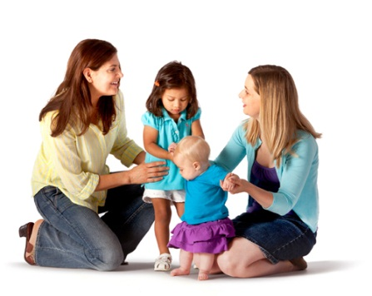
Youth under the age of 14 must be accompanied in the facility by a parent or guardian age 18 and older that must remain in the facility. Children under 9 must remain with a parent or guardian at all times unless registered in a supervised program or class.

Child Watch
Healthy parents are happy parents. Drop off your child in our supervised playroom while you take some time (up to two hours per day) for yourself. This is a free member service for children ages 6 weeks to 13 years old with a Y membership. All participants must be signed in/out of Child Watch by a parent, grandparent, or legal guardian. Parent/guardian must remain on the premises at all times. The prospective member fee is $5.00 per day.

Lost and Found
The Y is not responsible for lost or stolen property; however, we do retain lost and found items whenever possible. Please contact the Y for the location of the lost and found. Items are kept for a 30-day period and then donated to charity.

Special Needs
The Y provides opportunities for people with physical and mental disabilities to use our facility and participate in programs. Please contact the Y about any accommodations needed for participation.

Towels
The Y offers free towel service to our members. Towels must be returned to designated bins throughout the facility before leaving. Guests and Prospective Members must provide their own towels.
Program Materials and Information
Program guides, schedules, and flyers describing YMCA services and programs may be obtained at the Y or online at k3ymca.org.

No Smoking and Drug Policy
The Y’s facility and grounds are drug and smoke free.

Suggestions/Comments
Your suggestions and comments are always welcome. Please contact any of our staff with your questions or suggestions. Written comment cards are available near the Welcome Center.

If you have a specific concern which has not been resolved, please feel free to contact the Membership Director.

Rentals
The Y facilities may be reserved for special occasions for a fee. Reservations can be made at 815-933-1741.

Emergency Procedures
- Evacuations: All emergency exits are clearly marked. Please familiarize yourself with their locations. Should an evacuation of the facility be required for any reason, follow the directions of the Y staff to ensure a safe and orderly exit from the building.
- Fire Alarm: If the fire alarm sounds, please STOP all activity and evacuate the facility immediately.

Accidents & Incidents
Contact a staff person immediately if there is an accident, injury, or unusual incident. Building Supervisors are available to assist you during evening hours and weekends. However, please be advised that you are participating in all activities at your own risk and are fully responsible for yourself, your children, and your guests.

Sexual Offender Background Check Policy
The Y strives to provide a safe and threat free environment. Anyone 16 and older, who is not a member or does not have a photo in our member database, is required to provide a photo ID with birth date and first and last name. Persons who are on the sexual offender registry are not eligible for Y membership, program participation, guest/visitor privileges, volunteer, or employment opportunities at the Kankakee Area YMCA.

CODE OF CONDUCT

The Mission of the Kankakee Area YMCA is “to put Christian principles into practice through programs that build healthy spirit, mind and body for all.” Our values include caring, honesty, respect, and responsibility. Respect for others through our actions is our central guide to help ensure that we enjoy a safe, welcoming and comfortable Y. Specific behavioral expectations while at the Y include:

Supporting the Y’s Mission
Modeling the values of caring, honesty, respect and responsibility.

Treating Others with Esteem
Avoiding the use of abusive, inflammatory, racially prejudiced, or offensive language, not engaging in physical or verbal conflicts with others, not participating in theft or vandalism.

Dressing Appropriately
Wearing clothes that match the Y activity (e.g., swimwear in pool) and that displays no vulgarity, profanity, or suggestive writing/graphics.

Displaying Sportsmanship
Refraining from divisive taunting, maintaining poise under stress, and acknowledging a good effort, by both teammate and opponent, during and after events.

Not Engaging in Sexual Activity, Harassment, and Obscene Displays or Conduct
No verbal or physical actions will be tolerated. Sexually suggestive clothing is prohibited.

Not Possessing Illegal Substances
Avoiding use of alcohol, tobacco, or other drugs. Alcoholic beverages and smoking are banned from the Y’s property/ sponsored activities, including all buildings, parking lots, and grounds.

Not Carrying Weapons
Bringing guns, knives, and other devices that may be used as weapons onto the Y’s property is not allowed. The police will be called immediately upon discovery of any weapon.

Not Misusing Photographic Devices
Cell phones, cameras and other photography equipment may not be used without individual consent of the subject and are strictly forbidden in locker rooms and restrooms.

Nurturing Children
Children are precious at the Y. It is incumbent upon every adult member to assist and guide them whenever necessary, and to report to staff any need for discipline.

Respecting and Caring for the Y’s Property
Refraining from littering, theft, and other vandalism. We ask members to immediately report any problems with equipment and/or facilities.

Promoting the Code of Conduct
The Y promotes the Code of Conduct by holding others responsible and liable for their actions, asking violators to change their behavior and/or reporting incidents to Y staff.

Adherence to the Code of Conduct is required as part of your Y membership. Not adhering to the Code of Conduct may result in penalties. The Y is the final arbiter in all cases.

FACILITY INFORMATION

Aquatics
"The BIG Three"
- All children under the age of 10 must be ACCOMPANIED BY AN ADULT. Any NON SWIMMERS must be accompanied IN THE WATER BY AN ADULT.
- Absolutely NO DIVING of any type is allowed. Including recreational and competitive "racing" dives.
- Any prolonged and/or repeated breath holding activities are strictly PROHIBITED.

Other Swimming Pool Rules/Courtesies
- Youth 18 and under must pass swim test before allowed in the deep end of pool.
- Non-swimmers and/or children with floatation devices must be kept within arm’s reach of an adult at all times.
- Only Coast Guard approved flotation devices are permitted for use by non-swimmers.
- Lifeguards are on duty to enforce rules and respond in case of an emergency.
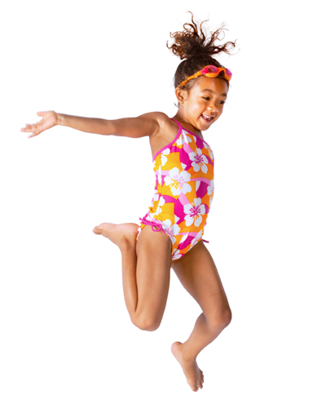
- Showers must be taken before entering the pool.
- Bathing suits are required. Gym shorts, cut-offs or street clothes are not allowed.
- Running, horseplay, dunking, pushing and profanity are strictly prohibited.
- Inflatable devices are not permitted (i.e. no rafts or water wings).
- Kickboards, flotation belts and other instructional devices are for swim classes and lap swimmers only.
- Food, beverages, gum, tobacco products, alcohol, glass containers and pets are not allowed.
- Young swimmers who are not toilet trained must wear appropriate swim diapers and rubber pants with elastic.

Lap Swimming Etiquette
- Please circle swim in order to allow multiple swimmers to use the same lane.
- Notify all swimmers in a lane of your presence before entering the water.
- Choose a lane based on your swimming ability. (Slow/Medium/Fast)
- If you need to rest in between laps, please do so at the extreme corner of the lane.
- Water jogging in lanes is only permitted when there are not multiple swimmers present.
- Please follow the lifeguard’s direction. We may need to move lanes in order to accommodate the aquatics schedule. Thank you for your cooperation!

Group Exercise
Age Guidelines
- Members ages 14 and older may participate in all group exercise classes.
- Members ages 10-13 may participate in classes only with instructor approval and if they are accompanied by an adult (age 18+) who is participating in the class.

Equipment
- Equipment should be returned to its proper storage place.
- Weight-bearing exercises should not be performed against the mirrors.

Proper Attire
- T-shirts, shorts, sweatpants, socks and closed-toe athletic shoes are acceptable.
- Street clothes— including jeans, sandals, street shoes, and swimsuits are not allowed.

Safety Guidelines
- It is highly recommended that you see a physician before beginning an exercise program, especially if you have any pre-existing medical conditions.
- Members must follow the class guidelines and instructor’s directions.
- To avoid class distractions, please turn off all electronic devices.
- Please secure your coats, gym bags and all other valuables in a locker.

Group Cycling
Rules of the Road
- Please bring a towel & water to class.
- Please silence all electronic devices.
- Make sure that all adjustments are tight before beginning class.
- If your feet slip from the pedals, use brake to make pedals come to a complete stop before attempting to put feet back into pedals.
- Compete with yourself, not with other class participants.
- Upon completion of class, please place all adjustments to their “max level”, keep adjustments loose, and wipe down bikes with cleaning supplies.

Gymnasium – Safe Gyms Have Rules
- Due to safety issues, no food or drink (including water) are allowed in gymnasium.
- Sport-approved and appropriate clothing and shoes must be worn at all times. Coats, bags and personal items must be stored in a locker, not on the gym floor.
- Dunking and hanging from rims are prohibited and will result in removal from the Y.
- Mishandling of balls and equipment is prohibited (no throwing, kicking, etc.).
- Disagreements, disputes and arguments will be settled in a polite, timely and nonviolent manner.
- Players are responsible for any damages resulting from misconduct or misuse of equipment and facilities.
- Players will conduct themselves in a sportsmanlike manner…profanity, spitting, unsportsmanlike conduct, provocative language and/or actions are prohibited.
- The Y is not responsible for lost or stolen articles. Please keep your items at home.
Locker Rooms
General Rules
- Please secure your belongings. Locks are available for purchase at the Welcome Center.
- Permanent locker service is available for an additional charge.
- Lockers are for daily use only, except for permanent locker service. All locks remaining at the close of business will be removed on a nightly basis. Removed contents are stored at the Welcome Center for 30 days. We are not responsible for the replacement of cut locks.
- Cell phone cameras and other photography equipment are strictly forbidden in locker rooms and restrooms.

Additional Rules
- Adult Locker Rooms – For men and women 23 years old or older. Access key is required to enter and can be obtained at the Welcome Center.
- Family Locker Room - For family use only. An adult must be present at all times. Please change clothing in the privacy rooms. Access key is required to enter and can be obtained at the Welcome Center.
- General Locker Rooms – For men and women 14 years old or older. No key is required to enter.
- Boy’s & Girl’s Locker Room – For youth aged 13 years old or younger. No key is required to enter.

Racquetball Courts
- Appropriate attire and proper shoes are required. GOGGLES ARE HIGHLY RECOMMENDED FOR YOUR SAFETY. For your convenience, racquets, racquetballs and goggles are available for checkout at the Welcome Center.
- Reservations can be made up to 72 hours in advance.
- Court Time Limit: 1 Hour
- Members may only reserve courts under their own names.
- No youth under the age of 12 will be allowed in a court or allowed to reserve a court without an adult present, between the hours of 5:00pm-7:00pm.
- Courts 1 and 2 will be reserved for racquetball or handball players between the hours of 5:00-8:00pm from Monday through Friday. Court 3 is reserved for racquetball or handball players between the hours of 5:00-8:00pm on Friday.
- Only YMCA Staff Members may enter a reservation into the reservation binder.
- Players must check in at the Welcome Center to confirm their reservation.
- Courts will be forfeited if, 15 minutes after the start of the scheduled reservation, the reserving member has not checked in.
Running/Walking Track
Age Guidelines
- Members ages 14 and older are permitted full use of the track.
- Members ages 10-13 must be accompanied by an adult.
- No one under the age of 10 is permitted on the track.

Proper Attire
- Proper workout attire and closed-toe athletic shoes are required.
- No sandals, swimwear, or clothing that may be inappropriate in a family environment.

Food
- Closed water bottles are allowed.
- No food or gum allowed on the track.

Track Etiquette
- Run or walk single file except to pass.
- No strollers.
- All walkers and slower runners keep to the inside rail.

Track Safety
- The use of dumbbells, balls, and open air stereos are prohibited. Spectators are not allowed on the track.

Wellness Center Guidelines
- Please secure your coats, gym bags and all other valuables in a locker.
- Cardiovascular equipment has a 30-minute limit during peak hours.
- Profane or indecent language is not allowed.
- Proper exercise attire (jeans are not permitted), especially footwear, must be worn at all times. Proper footwear includes walking or athletic shoes with rubber soles designed for physical activity. Open-toed shoes are not permitted.
- Cell Phones: Phone calls or use of recorders and cameras are not allowed in the Wellness Center.
- Youth 10-13 years old are permitted to use the Wellness Center after completing the Fit Pass Orientation (FPO). FPO graduates must wear their FPO lanyard in the Wellness Center at all times.
- Outside personal trainers or coaches are not permitted to work with or train YMCA members or guests.

Wellness Center Etiquette
- While performing workout sets, be mindful of others waiting. Do not rest on the machine between your sets. Allow others to perform a set while you are at rest.
- Pease do not use machines or benches for sitting or anything else besides their primary purpose.
- Pease raise and lower weights in smooth, fluent motions. Do not “bang” weights.
- Do not drop free weights and/or dumbbells on the floor carelessly.
- Exercise balls have recommended weight limits. Do not add additional weight when using them (e.g. hand weights and bar bells).
- Always return weights to their proper storage area when finished.
- Wipe off machine and equipment when you are finished.

WHAT TO DO IF SOMEONE IS USING THE MACHINE YOU WANT:
- Ask if you can perform a set while they are at rest between their sets.
- Ask them how many sets they have remaining on the respective bench or machine.
- Avoid “hovering” or pressuring the person working out to stop. Please wait your turn.
- If you need help, please contact the Y staff on duty.

PROGRAM INFORMATION

Program Fees
Specific program date, time, and fee information is available in our Program Guide and online. Program fees are set to provide quality services and represent the cost of providing activities or services not included in your membership dues. Members receive a reduced rate on almost all programs.

Program fee refunds are made only when there is a cancellation of the activity due to insufficient enrollment, a verified medical illness, or with Director approval.

Preschool Child Care
The Y Preschool provides an enriching, nurturing environment that fosters learning and social development for the most important preschool years. Our High Scope Curriculum embraces a hands-on learning approach using people, objects, events and ideas in the areas of art, science, social-emotional development, language, literacy, math, movement, and music. Children will also have the advantage of utilizing the full YMCA facility that includes on-site YMCA progressive swim lessons, full size indoor gym and our rock climbing wall. CCR&R funding is accepted and financial assistance is available for those that qualify. Part day child care is available. Contact our Membership Director at 815-933-1741, ext. 233.

School Age Child Care
The Y is the largest provider of school age child care programs in the United States. Children are given a safe and fun place to be before and after school. We provide school age child care programs for the convenience of working parents. On most days that school is out, including parent teacher conferences and winter/spring breaks, the Y provides the School’s Out Days Program. This program is made up of a variety of activities at the YMCA, which may vary based on which school districts are out. The Y currently serves the following school districts: Bourbonnais, Kankakee and Momence. Contact our Youth & Teen Coordinator at 815-933-1741, ext. 227 for more information.
Summer Day Camp
If you are looking for summer activities for your preschool and school aged children, check out our Summer Day Camps. Our structured programs are fun, educational, and full of adventure. Day Camp at the Y is also a great experience during those long breaks from school. Campers have the opportunity to grow in spirit, mind, and body with other children. Contact our Youth & Teen Coordinator at 815-933-1741, ext. 227 for more information.
Aquatics
The YMCA is the nationwide leader in helping people of all ages feel safe in the water. Each year, the Y teaches thousands of children and adults to swim and certifies a majority of area lifeguards. Whether it’s participation in swim lessons, birthday pool parties, or swim team, you'll find water fun at the Y.

Fitness & Wellness
Which direction is your wellness journey taking? Are you marching towards high blood pressure, obesity and depression? Or are you taking control of your journey and heading towards total wellness? The Y offers multiple programs to keep you engaged, inspired and efficient in your path towards wellness. We offer:
- Wellness Assessments
- Group Cycling
- Group Exercise
- FREE Personal Training
- Personal Yoga
- Personal Pilates
- Pound by Pound Challenge

Whether you are taking the first steps in your journey, you've fallen off the trail and are ready to get back on, or you've been on the path for a while, the Kankakee Area YMCA has something to offer you!

STRONG KIDS CAMPAIGN

In support of the Y’s Mission, a Strong Kids Campaign is conducted each year from February through April. This campaign raises funds to provide children and families with the opportunity to participate in Y programs such as summer day camp, child care, youth sports and swim lessons. These families would otherwise be unable to participate due to their financial situation.

As a Y member, you have the opportunity to participate in the annual Strong Kids Campaign. All Y campaigners are volunteers, dedicated to helping others within the Y family. Training is provided and new campaigners are always welcome. Please consider a donation to the campaign and/ or volunteering to help raise funds. Contact the CEO for more information.

If you or someone you know is in need of financial assistance, please contact one of our member service representatives. All requests are confidential.
VOLUNTEERS

Every year thousands of volunteers support the Y’s overall purpose of helping people reach their God-given potential in spirit, mind, and body. Volunteers are needed today for:
- Youth Sports Coaches and Referees
- Special Events
- Youth Programs
- Board of Directors/ Committees
- Pioneering Healthier Communities
- Teaching Skills
- Administrative Tasks
- Fundraising
- Maintenance

Become a vital part of the Y community - your special talents will really make a difference!

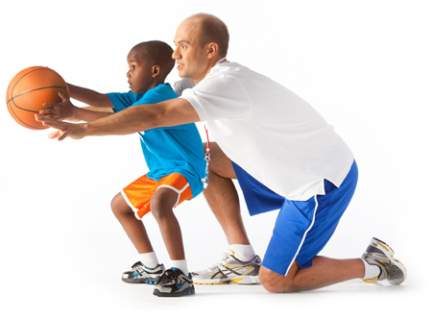

facility maps

